Indoor Scavenger Hunt

- Find a fork.
- Find something that is red.
- Find a tissue box.
- Find three things that have wheels.
- Find an orange crayon.
- Find something that is very soft.
- Find a key.
- Find two socks that match.
- Find something round.
- Find a sticker.
- Find a rubber band.
- Find a pair of glasses.
- Find an envelope.

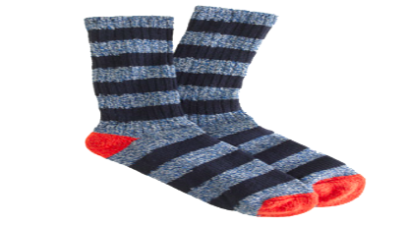
This Photo by Unknown Author is licensed under CC BY-NC
This Photo by Unknown Author is licensed under CC BY-NC

Inventor Scavenger Hunt

- Find something that you can turn.
- Find something that is bumpy.
- Find something that is metal.
- Find something you put together.
- Find three things that are round.
- Find something you twist.
- Find something shiny.
- Find something you can roll.
- Find a tube.
- Find three things that are squishy.
- Find something clear.
- Find something that can bounce.
This Photo by Unknown Author is licensed under CC BY-SA

Book Scavenger Hunt

- Find an animal in a book.
- Find phase2/3 tricky words in a book.
- Find someone helping in a book.
- Find a picture of a sun in a book.
- Find a picture that makes you laugh.
- Find a bug in a book.
- Find someone sleeping in a book.
- Find a character eating in a book.
- Find a dog in a book.
- Find a cat in book.
- Find a superhero in a book.

This Photo by Unknown Author is licensed under CC BY-SA-NC
Maths Scavenger Hunt
Items and numbers can be changed/adapted to suit individual children.

- Find 7 pencils and 1 blue crayon. How many items do you have altogether?
- Find 8 blocks and 2 pennies. How many items do you have now. Take away 3 blocks. How many items are left?
- Find 4 socks and 5 toys. How many items do you have now?
- Find 8 raisins (or some other food item) Eat 4 of them. How many are left?
- Find 3 spoons, 4 books and 2cups. How many items do you have altogether?
- Count all the tins of food in your kitchen!
- Can you count all your books?

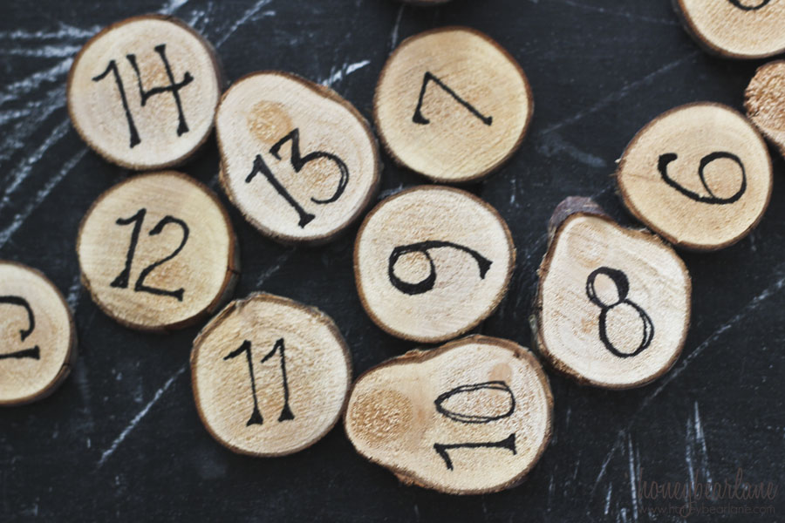
This Photo by Unknown Author is licensed under CC BY-SA-NC
Outdoor Scavenger Hunt

- Find 3 kinds of leaves.
- Find something white or yellow.
- Name a bug that is red.
- Find 4 sticks the same length.
- Find something that smells nice.
- Name the things you can see in the sky.
- Find a bird.
- Find some water.
- Find something that crawls.
- Find a feather.
- Find a spider web! Can you find the spider?

